
Experiment 6: CDN SERVICE SELECTION AND CDN CONFIGURATION.
AIM:
To select a Content Delivery Network (CDN) provider, deploy a simple web application using Cloudflare, access the application through Cloudflare's edge network, and verify the HTTP response and Cloudflare-specific headers using browser Developer Tools.
PROCEDURE:
- Select the CDN Provider:
Cloudflare was selected as the CDN/edge provider because it provides CDN, security, DNS, and edge computing services
- Login to Cloudflare:
Open the Cloudflare dashboard and log in to the Cloudflare account. No DNS or nameserver settings were changed.

- Create a Worker:
From the Cloudflare dashboard, click Create app and select Start with Hello World!.
- Configure the Worker:
Keep the automatically generated Worker name and the default Hello World code without making any changes.
- Deploy the Worker:
Click Deploy and wait for Cloudflare to complete the deployment. A public workers.dev URL is generated after successful deployment.

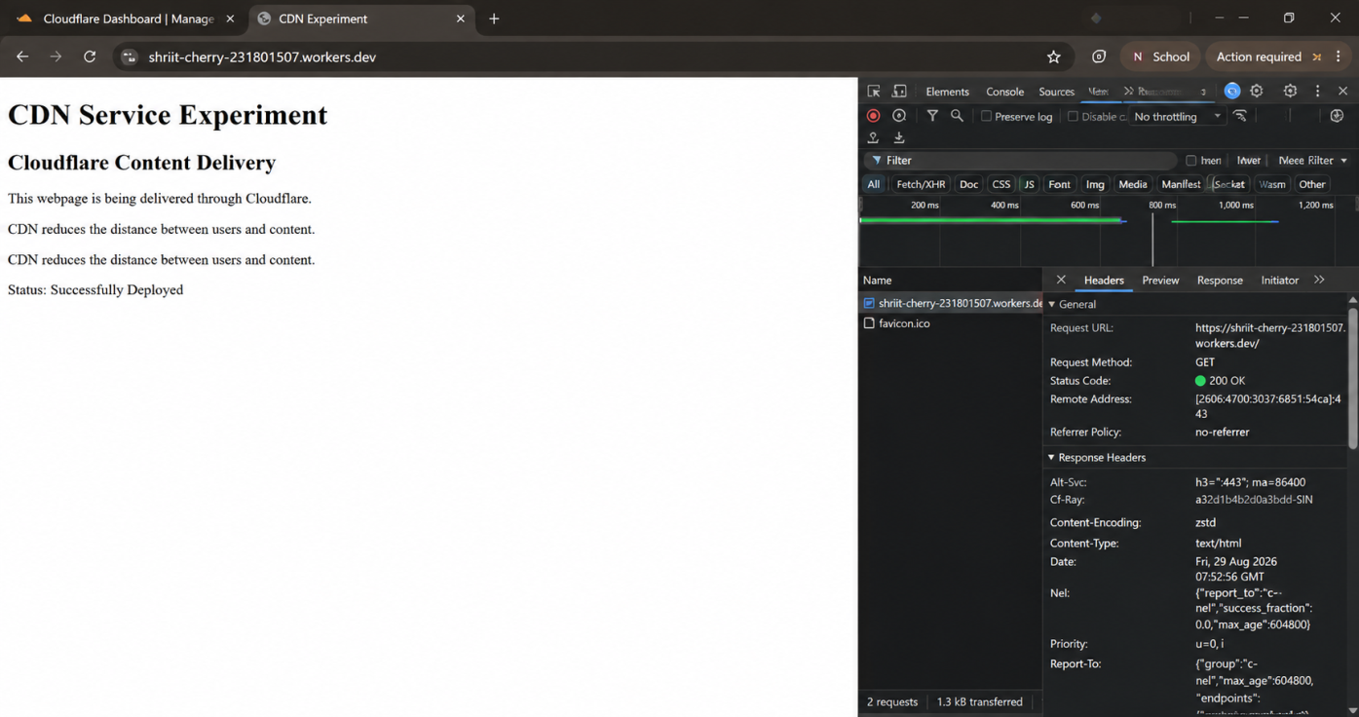

- Test the Worker:
Click Visit to open the deployed Worker in a new browser tab and verify that Hello World! is displayed.
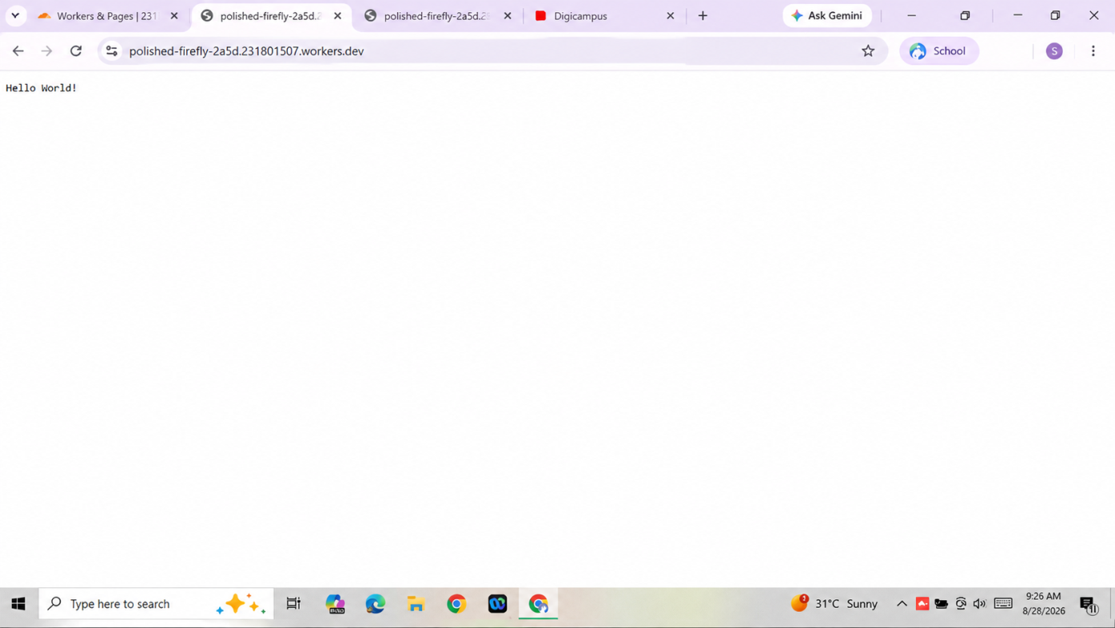
- Verify Invocation:
Return to the Cloudflare dashboard and check the Invocations metric. After accessing the Worker, the invocation count increases.

- Create the CDN Experiment Page:
Open Edit code and replace the default Hello World code with an HTML webpage describing Cloudflare content delivery. Then click Deploy.

- Test the CDN Webpage:
Click Visit again and verify that the CDN Service Experiment webpage is displayed successfully.
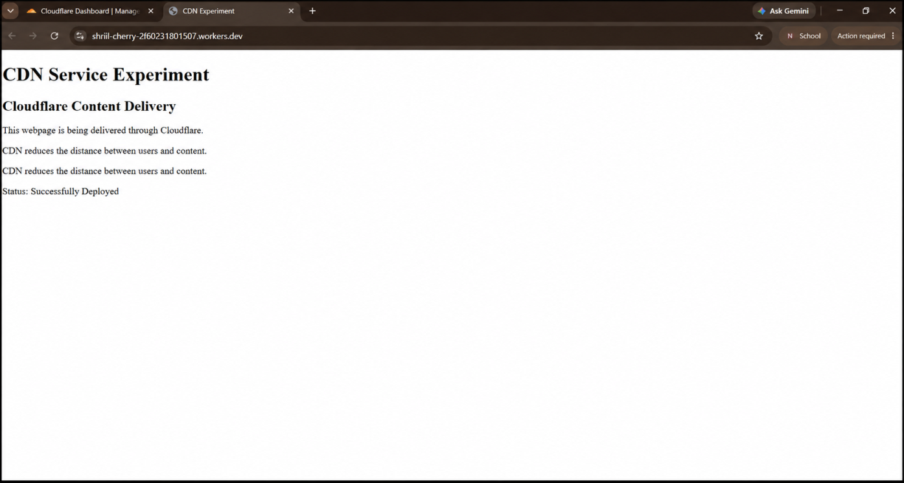
- Verify HTTP Response:
Open the webpage, press F12, select Network, and press Ctrl + R. Select the request corresponding to the workers.dev URL.

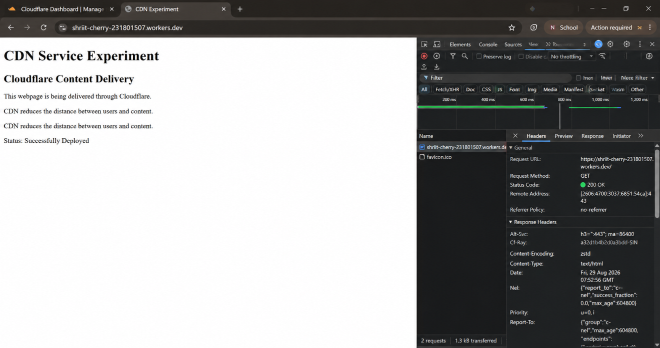

- Verify Response Headers:
In the Headers section, verify:
  - Request Method: GET o Status Code: 200 OK o Server: cloudflare
  - CF-Ray
  - Content-Type: text/html

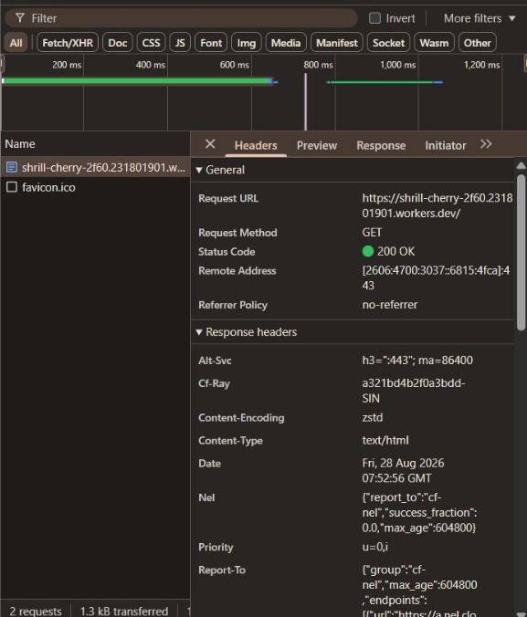
- Confirm Successful CDN Deployment:
The successful HTTP response and Cloudflare-specific headers confirm that the webpage was processed through the Cloudflare network.

CONCLUSION:
The CDN service selection and configuration experiment was successfully completed using Cloudflare Workers. A Worker was deployed and accessed through a public workers.dev URL. The CDN experiment webpage was successfully displayed, and the browser received a 200 OK response. The response headers showed Server: cloudflare, CF-Ray, and Content-Type: text/html, confirming that the request was processed through the Cloudflare network.

